**Tilt Built**

Have you heard of “ Leaning Tower of Pisa” - who hasn’t…

It’s an amazing art of civil engineering.

So here we are presenting the task to you to build your own model of leaning tower using popsicle sticks.

## ****PROBLEM STATEMENT:****

• We bring you the challenge to design a Leaning Tower using Popsicle sticks (ice-cream sticks) & fevicol , which can sustain maximum load, maximum leaning angle and satisfy the stated constraints.

## RULES

• Team can comprise maximum of 4 members.

• Registration fee is Rs 60/- per team.

• The leaning tower should be made with popsicle sticks.

• Interdisciplinary participation is allowed.

• The final selected teams will present their model in exhibition during Mindbend 2012.

• The winners will be selected on the basis of total points secured by the team according to formula, given in judging criteria.

The decision of judges will be final and binding.

## SPECIFICATIONS:

• Material Constraints:

1. Popsicle sticks (maximum length 110 mm, width 13 mm and thickness 3 mm) and adhesive (fevicol) can only be used to build the structure.

2. Adhesive can be used to join Popsicle sticks together .However adhesives cannot be applied on the free surface of a member made of Popsicle sticks to increase its strength (Adhesives such as M-Seal or Fevi-qwik are not allowed).

3. The Popsicle sticks and toothpicks can be cut or trimmed to any shape or size.

4. Structures built using any other materials except those mentioned above will be disqualified.

TEST CONDITIONS

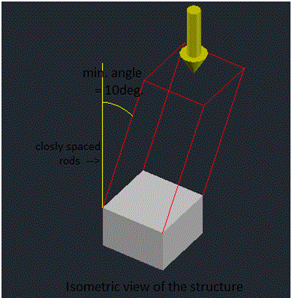

1.Prior to evaluating the structure, the dead weight (m) is measured and recorded in grams.

2.The team members will decide how much weight should be kept initially. The weights will be kept on the middle of the top flat surface of the structure.

3.After that weight will be increased in 1 kg intervals (or according to situation) and the ultimate load carrying capacity (Fu) of the structure will be evaluated at the point of failure.

**Definition Of Failure:**

1.The structure is considered failed when:

* The vertical deflection exceeds 50mm, i.e. the vertical height reduces by 50mm or more due to bending.
* Any member or joint fails.
* At any point of time, the structure, other than foundation, touches the platform.

**Judging Criteria:**

**1.Structural Efficiency(E)**)

• The structural efficiency will be calculated by the following equation:

E=(Fu)÷(m*10)

Where

Fu= Ultimate load taken by the structure (kgf).

m= Dead weight of structure as measured at the competition (kgf).

**2.Vertical height-load factor (HLF)**

HLF= Vertical height of structure above the base (in mm) * √ (load in kg)

**3.Inclination-load factor (ILF)**

ILF= (Angle (in minutes) with vertical) * ∛ (load in kg)

**4.Ultimate Load Bearing Capacity (Fu)**

Fu=maximum load taken by the structure (in kg.f).

**5.Leaning Angle(LA)**

LA= leaning angle of the s

• In each category, there will be maximum points for the highest scorer and minimum points for the lowest scorer, and all others will be awarded points based on their points in that category, linearly in between maximum and minimum.

• Judging category, maximum points, and minimum points are as follows:-

Judging category    maximum points     minimum points

E                                    150                                 30

HLF                               150                                30

ILF                                 100                                20

Fu                                   75                                 15

LA                                  50                                 10

• Thus the formula for total points:-

Total points=E+HLf+ILf+Fu+LA

• So maximum Total Points=200+150+100+75+50

=525 points

Structural constraints and penalty:-

•The structure should have a minimum base area of 100*100 mm.sq. and maximum area of 200*200 mm.sq. i.e. it should fit within the square of area 200*200 mm.sq.

• Structures with base area more than 200*200 mm.sq. will have the following penalties applicable:-

.  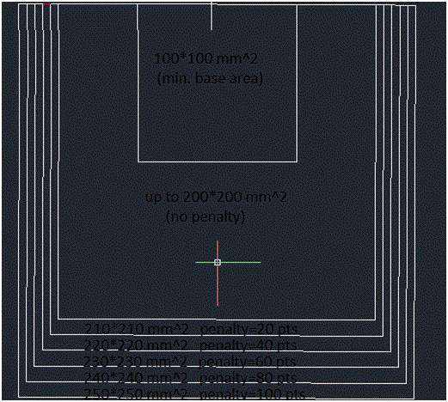

• If the base doesn’t fit in square of 250*250 mm.sq. , it will be disqualified.

• The structure should have a base foundations of maximum 100 mm in height below the leaning structure as shown in the fig.

• Height of the leaning structure will be measured from above the height of the foundation .The structure should have a minimum vertical height of 350 mm above the foundation. Structures having vertical height less than 350 mm will be disqualified.

• The dead weight of the structure should not exceed 1.5 kg, after 1.5 kg there will be penalty of 40 points at every 0.1 kg increment in the self weight of the structure. After 2kg weight structure will be disqualified.

• Angle made by the leaning structure with the vertical will be measured from above the foundation to the highest point of the structure using the formula:

http://www.mindbend.in/fr.gif

• The minimum angle of the structure with vertical should be 10 degrees.

• The structure should be symmetrical from outside, i.e. all sides of leaning structure should be uniformly inclined with same angle inclination.

• The foundation of the structure will be tied with threads to hold the base tightly.

• The top slab (surface) must be provided but its thickness should not be more than 12mm.Top surface should be flat and parallel to ground surface. This is required in order to help you balance the load easily on the top surface.

• The structure should not be externally supported by means of columns & beams. Inside the structure you can provide supports like columns, trusses, beams,etc.

